How to use this template

This template is for community club use as a guide to developing a strategic plan. All photos, colour themes, fonts and sizing can be customized to club content.

All content in the template is intended as examples only. Clubs are encouraged to change content to club specific information.

Adding Club Logo:
The club logo can be added to the cover page of this document.

- Right click on logo square
- Select “Change Picture”
- Add club logo as a JPEG

Picture effects and transparency can be change in the Picture Formatting tab.

Changing picture background:
All backgrounds can be changed or deleted as required. The background has been added to the header of the page to prevent accidental formatting of the photo.

- Double click on the header of the document.
- Right click on the picture
- Select “Change Picture” option
- Add a club picture of your choice

Picture effects and transparency can be change in the Picture Formatting tab.

Changing photos:
All photos can be changed to club specific photos. Photos used throughout the template are intended for examples only.

- Right click on the picture
- Select “Change Picture” option
- Add a club picture of your choice

Picture effects and transparency can be change in the Picture Formatting tab.

Changing text:
Text boxes have been used throughout the document. Click on each text box to edit content, formatting, or position. Delete the explanation text when no longer needed.

** Delete this page when no longer required **

CLUB NAME

STRATEGIC PLAN
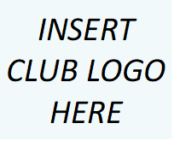
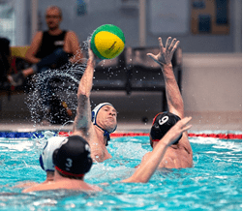
07
08
10
10
11
12
03
04
04
05
05
06
Forward
Club Information
Committee Charter
Population and Demographics Membership Profile
Financial Summary
Facility Profile
SWOT Analysis
Vision Statement
Mission Statement
Values
Strategic Framework
FORWARD

This Plan will be tabled at each meeting of the Executive Committee to ensure that it is implemented throughout the year and that specified timeframes are being met.

CLUB NAME will also hold an annual planning review workshop in line with its AGM to ensure that this plan is updated each year.

CLUB NAME will consider the following groups and individuals within this planning process.

• Members
• Volunteers
• Sponsors
• Local Government
• Club Committee
• Etc.,

The CLUB NAME Strategic Plan was formulated in 202x by <who>.

The process included a planning workshop, involving all key stakeholders.

This broad involvement was intended to ensure that the objectives and strategies contained within the Plan were fully representative of the entire membership of the club.

The workshop was held at <location and dates>. The information contained within this Plan was gathered from this workshop and from further consultation undertaken within the club.
CLUB INFORMATION

Committee Charter/Organisation Chart

Add a summary of the structure of committee/s including names and roles.

Population and Demographics

Add information about population base of your club local area.

Club Membership Profile

There are a total of XXX members at the Club.
  - Senior members: (insert no.)
  - Junior members: (insert no.)
  - Masters: (insert no.)
  - Social Members: (insert no.)
  - Other Members: (insert no.)

Include information about further demographics e.g. XX% from multicultural background, XX% have a disability, XX%

Financial Summary

Add a summary of club’s financial health. This information can be found in the club’s annual report.

Venue/Facility Profile

Include information about training and competition location and history and if other have access to location.

SWOT ANALYSIS
STRENGTHS | WEAKNESSES
Insert answer here | Insert answer here
OPPORTUNITIES | THREATS
Insert answer here | Insert answer here

VISION STATEMENT

Enter Club Vision Statement Here

A vision statement describes what a club wants to achieve in the long-term, creating a picture what the club will look like in the future and sets a defined direction for the planning.

.
MISSION STATEMENT

Enter Club Mission Statement Here

A mission statement is a sentence or short paragraph that defines the purpose of the club. It answers why the club exists.
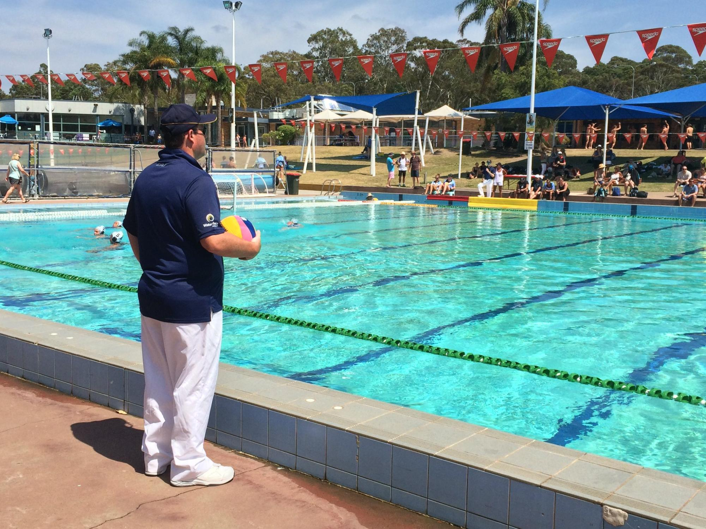

VALUES

Value – add information about what it means to your club
1
Values are what the club believes in – they are the core beliefs and shapes all behaviour.
Value – add information about what it means to your club
3
Value – add information about what it means to your club
Value – add information about what it means to your club
4
2
STRATEGIC FRAMEWORK
Key Objective | Strategic Initiatives | Key Performance Indicators
Grow awareness, participation and new  opportunities | - Design and deliver a senior citizen program  - Host 2 “Open Days” annually inviting the local community to trial a training session | - Delivery of program/ increase in membership  - Hosting of events/increase in membership/increase in awareness
Establish strong governance structures | - Ensure financial reporting compliance annually  - Establish safeguarding children policy
Improve financial sustainability of the club | - Secure sponsorship deals for the club  - Secure grants
Improve training environment | - Upgrade training equipment  - Host team dinners once a month

Key Objectives: the results a club hopes to achieve when attempting to pursue its vision and purpose within the time frame of the plan.

strategic initiatives: strategies and tasks a club will perform to achieve its objectives.

Key Performance Indicators: identify the criteria used to measure performance against each strategic priority.

