How to use this template

This template is for community club use as a guide to developing a sponsorship proposal. All photos, colour themes, fonts and sizing can be customized to club content.

All content in the template is intended as examples only. Clubs are encouraged to change content to club specific information.

Adding Club Logo:
The club logo can be added to the cover page of this document.

- Right click on logo square
- Select “Change Picture”
- Add club logo as a JPEG

Picture effects and transparency can be change in the Picture Formatting tab.

Changing picture background:
All backgrounds can be changed or deleted as required. The background has been added to the header of the page to prevent accidental formatting of the photo.

- Double click on the header of the document.
- Right click on the picture
- Select “Change Picture” option
- Add a club picture of your choice

Picture effects and transparency can be change in the Picture Formatting tab.

Changing photos:
All photos can be changed to club specific photos. Photos used throughout the template are intended for examples only.

- Right click on the picture
- Select “Change Picture” option
- Add a club picture of your choice

Picture effects and transparency can be change in the Picture Formatting tab.

Changing text:
Text boxes have been used throughout the document. Click on each text box to edit content, formatting, or position.

** Delete this page when no longer required **

CLUB NAME

SPONORSHIP PROPOSAL
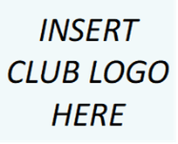
DATE
ADDRESS
NAME

Dear BUSINESS OWNER,

I am contacting you on behalf of CLUB NAME as we are seeking new club sponsors for the NEXT NUMBER OF YEAR(S) ahead. I am NAME OF PRESIDENT of the club and would welcome the opportunity to discuss a sponsorship with your business.

(Introduce the Club and a brief outline describing how the business will benefit from being involved with the club e.g., club growth rate, inclusive environment, family friendly, values etc).

I would like to offer BUSINESS NAME the opportunity to become a sponsor of CLUB NAME for the LENGTH OF CONTRACT.

Becoming a sponsor of CLUB NAME helps us provide vital equipment, facilities and resources to support water polo from grassroots to senior competition. Our main objective with Sponsorship is to make it possible for sponsors to be able to assist our great club whilst providing sponsors with as much exposure as possible.

This document will provide you with some more information about the Club and its sponsorship offerings, as well as the benefits that BUSINESS NAME will receive as a Sponsor of the Club.

If you require any further information, please do not hesitate to contact myself on the details provided below. We hope to have confirmed all new club sponsors by INSERT DATE.

Thank you for your consideration.

With Regards,

NAME
POSITION
CLUB NAME
MOBILE NUMBER
EMAIL ADDRESS
OUR CLUB

MEMBERSHIP

Our teams participate in COMPETITION NAME at AGE GROUPS.

There is a total of NUMBER members at the Club.
  - Senior members: (insert no.)
  - Junior members: (insert no.)
  - Masters: (insert no.)
  - Social Members: (insert no.)
  - Other Members: (insert no.)

We have seen NUMBER % of growth over NUMBER of years while expecting NUMBER % of growth in the next NUMBER of years due to REASON.
ACHIEVEMENTS

- DIVISION – CHAMPIONSHIP – YEAR
- DIVISION – CHAMPIONSHIP – YEAR
- DIVISION – CHAMPIONSHIP – YEAR
- DIVISION – CHAMPIONSHIP – YEAR
MISSION AND VALUES

CLUB NAME mission is to ENTER CLUB MISSION STATEMENT

CLUB NAME also proudly upholds our values of:
1. CLUB VALUE ONE
2. CLUB VALUE TWO
3. CLUB VALUE THREE
4. CLUB VALUE FOUR
5. CLUB VALUE FIVE

The CLUB NAME is a local community water polo club that was formed in YEAR. The club is based at LOCATION where we have been based since YEAR.

Our club is a proud “not for profit” Community Club with our main objective being to provide social enjoyment and physical activity for all ages and all skill levels. We have teams from AGE GROUP to AGE GROUP.

The Club has a very strong focus on community involvement participating in LIST COMMUNITY INITIVES/FUNDRAISING.
THE BENEFITS
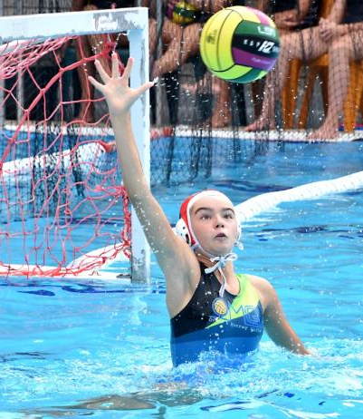
- NUMBER Facebook page followers
- NUMBER Instagram page followers
- NUMBER e-newsletter subscribers
- NUMBER members within the club
- YEAR of DIVISION CHAMPIONSHIP
- NUMBER user access training facility
KEY FACTS
As sponsor of CLUB NAME, you and your business will not only become part of a local sporting club but also form a partnership with a growing community group that supports its players and families by providing a safe and inclusive place to belong.

Some of the benefits include:
- Involvement & support of a local sporting community organization
- Exposure to local families living within your community.
- Opportunity to develop relationships and broaden networks with a range of key groups, potential clients/customers, and stakeholders.
- Opportunity to reward your valued customers/clients with the involvement in various club events including LIST SOCIAL EVENTS
- Access to communicate directly with members, guests and the greater community of SUBURB and surrounding areas.

VISION STATEMENT

Enter Club Vision Statement Here

A vision statement describes what a club wants to achieve in the long-term, creating a picture what the club will look like in the future and sets a defined direction for the planning.

.
MISSION STATEMENT

Enter Club Mission Statement Here

A mission statement is a sentence or short paragraph that defines the purpose of the club. It answers why the club exists.
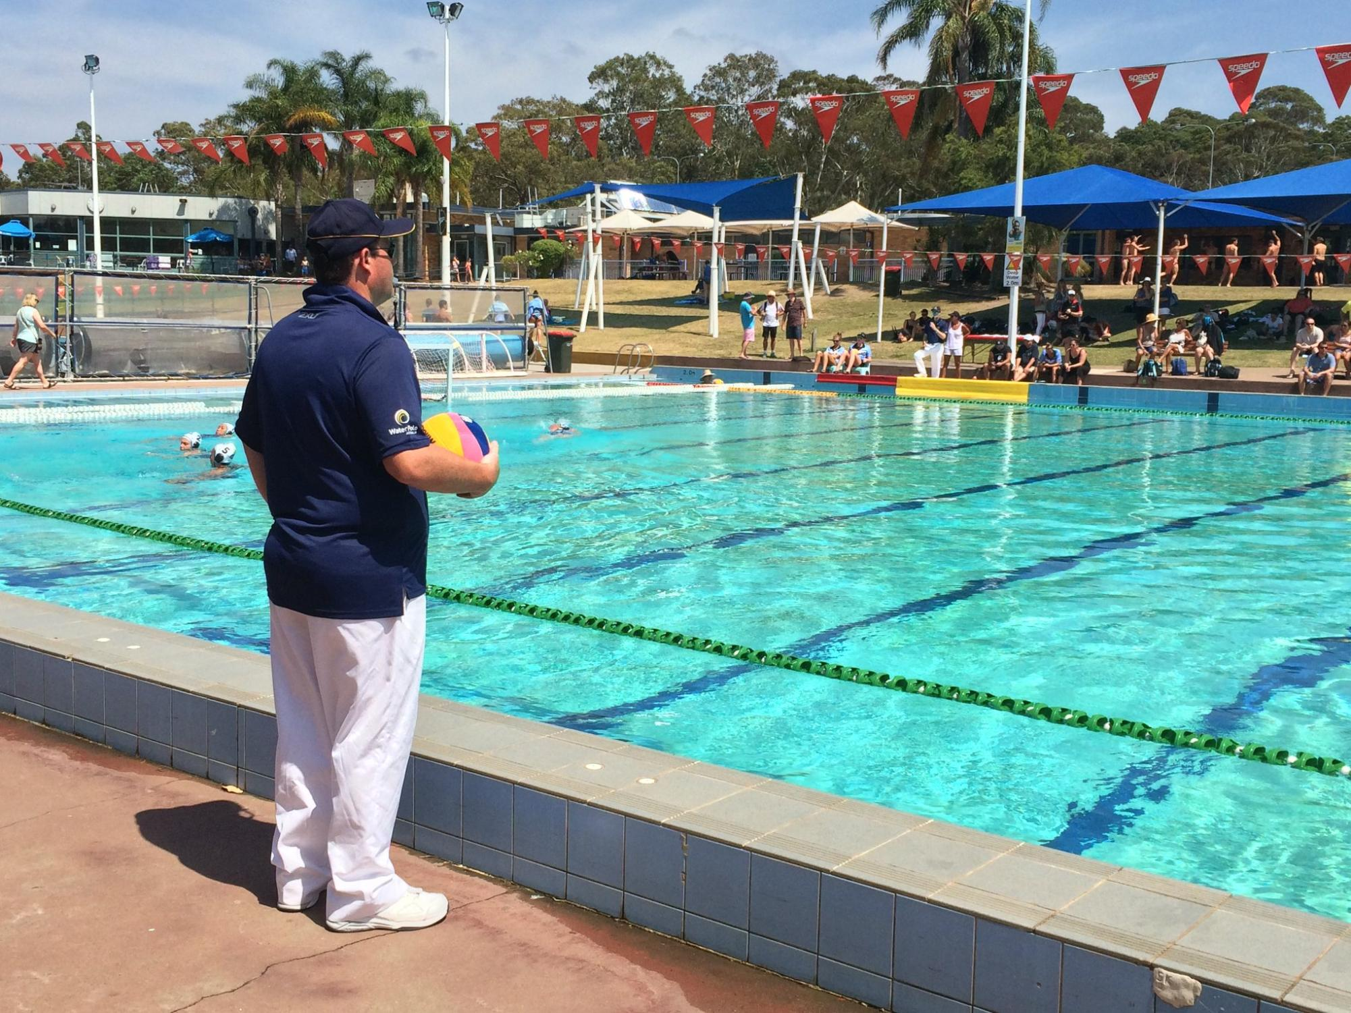

VALUES

Integrity – add information about what it means to your club
1
Fun – add information about what it means to your club
3
Passion – add information about what it means to your club
Inclusive – add information about what it means to your club
4
2
SPONSORSHIP
BENEFITS

The benefits detailed in the section below are in draft and are open for negotiation. Our aim is to tailor the partnership benefits to suit the Sponsor’s needs.

- Official Designations
  - (Major/minor) Sponsor of the Club.
  - (Major/minor) Sponsor of XXX Team
  - (Major/minor) Sponsor of EVENT NAME
  - The SPONSOR NAME Award presented at annual awards

- Use of Logos/IP
- The right to use the Club’s logo in connection with this sponsorship.

- Sales lead generation
- Access to the Club’s members, umpires, coaches and supporters via our Club database for the purpose of advertising and communication special offers to Club members in line with privacy laws.
- 1 x Club newsletter posts per year of the sponsorship

- Membership
  - 1 x Club Membership.

- Branding
- Logo on club merchandise.
- Logo on all official publications and invitations produced by the club, including invitations for events, Club brochures and manuals.
- Hospitality & Networking
  - 1 x ticket to the Sponsors Day.
  - 1 x complimentary ticket to the Annual Awards Night.

- Signage
- 1 x External signage.
- 1 x Internal signage.

- On-line
- Logo recognition and link on the Club website
- Website news article and Facebook Page post announcing the sponsorship.
- 2 x Facebook/Instagram posts per year of the sponsorship

CLUB NAME BENEFITS

List the sponsorship benefit/s to the Club here (e.g. $2000 cash sponsorship to fund the team, including jersey design and production).

TERM OF PARTNERSHIP

It is proposed that this sponsorship would be for the (insert year, e.g. 2021) and (insert year, e.g. 2025) calendar years.

